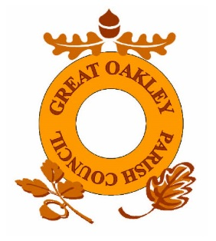
GREAT OAKLEY PARISH COUNCIL
Needs your help

Would you like to become a Parish Councillor and help maintain Great Oakley & Stones Green for future generations?

Represent the community and have your say regarding:
- Planning
- Highways
- Community Support / Local Amenities
- Village Hall
- Public Rights of Way
- Parking
- Street Lighting
- Parks and Open Spaces

Great Oakley Parish Council currently have 6 Parish Councillors who meet once a month to discuss these issues and more, helping to make our Parish a pleasant place to live in and protect it for future generations.

We currently have 3 vacancies for Parish Councillor so if you have some time to help make a difference we would love to hear from you.

Please contact Jayne by email gtoakleypc@aol.com
Or letter to
33 Orchard Close, Great Oakley, Harwich, Essex, CO12 5AX expressing your interest.

